¿Cómo se llaman esto personajes principales? (*What are these main characters’ names?*)

 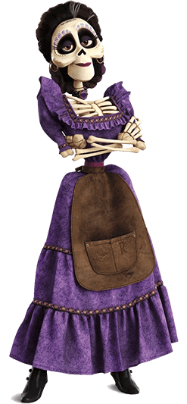  

______________ _______________ _______________ _______________

**Contestar en inglés (*Answer in English*)**

* 1. a. ¿Dónde transcurre la película de Coco? (*Where does* Coco *take place?*)
  2. b. ¿Cuándo transcurre la película de Coco? (*When does Coco take place?*)
  3. c. ¿Cómo refiere Miguel a su abuela? (*How does Miguel refer to his grandma?*)
  4. d. ¿Qué están celebrando al principio de la película? (*What are they celebrating at the beginning of the movie?*)
  5. e. ¿Qué es la tierra de los muertos? (*What is the Land of the Dead?*)
  6. f. ¿Quién es Coco? (*Who is Coco?* )

**Simbología (*Symbology*)**

Coco is full of Mexican **symbology**, where in the movie can you see the following and what is their meaning?

* Orange flower petals (Cempazuchitl flower)
* Family members portraits
* Altars or “Ofrendas”
* Papel Picado (chopped paper)
* Velas

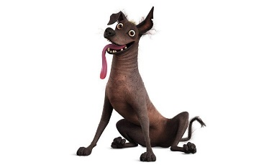**Trabajo de investigación (*Research work*)**

Dante, Miguel’s dog, represents *Xoloitzcuintli*. What or who is Xolo?

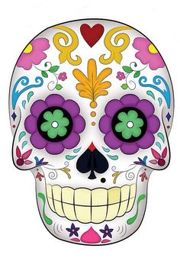

These are known as “calaveritas”. Where in the movie can we see them and what do they represent?

What is “La llorona” in the song that Mama Imelda sings on the stage?

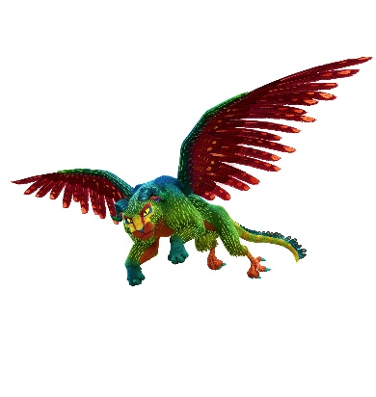

This is an “Alebrije” find more information about these creatures.

What is this character’s name? who is she representing? Find more information about her.

